Algorithms for Machine Learning

# 1. Linear Regression

Linear regression is a ML algorithm through which we develop a linear model of the data, and use it to perform prediction.

The basic step of performing regression is

• Define a model

• Define optimisation function

• Optimise the model using the loss function using any optimisation algorithm

• Evaluate result

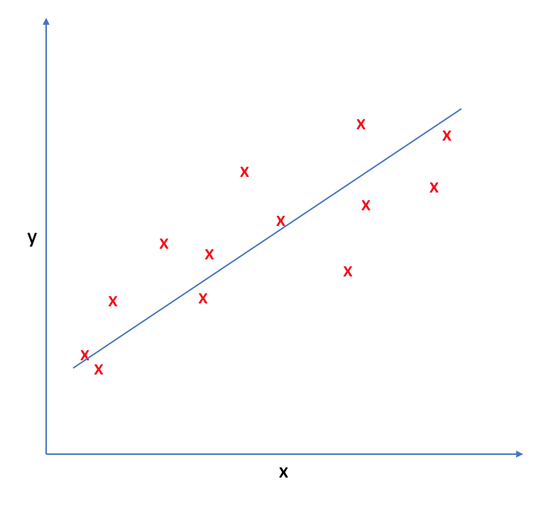

There are two types of linear regression:

**1. Simple linear regression:**

Uses **f(x) = w.x + b** as the model, where w and b are real number values.There is only one feature variable x to create the model, and the prediction y. The model ends up being a line in 2-dimensional plane.

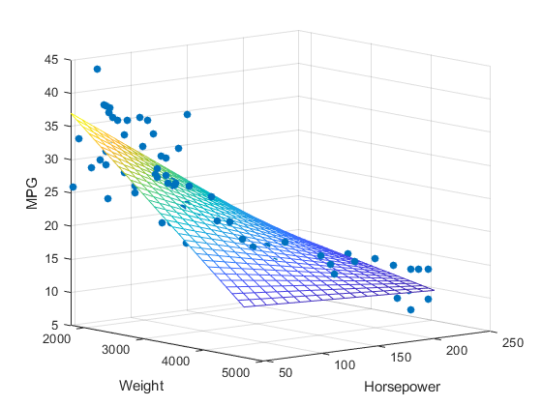**2. Multiple linear regression**

In multiple linear regression, there are multiple feature variables and their corresponding weights. If there are n feature variables, the model will be a n+1 dimensional hyperplane in an n+1 dimensional space, with one dimension referring to the prediction value f(x).

The model is represented as

**f(x) = w1.x1 + w2.x2 + . . . +wn.xn +b**

or as f(x) = w. x + b, where w and b are n-dimensional vectors and . Represents dot product between w and x.

#### 1) Defining model

The equation of linear model, used in simple linear regression is

**f(x) = w.x + b**

We will use some optimisation algorithm (like SGD, OLS, etc.) to find the optimal values of w(weights) and b(biases), denoted as w* and b*, by defining a loss function, and trying to minimise it.

#### 2) Optimisation function

The cost function is the function which is being optimised(minimised) inorder to get the optimal values w* and b*. For linear regression, the most common loss or cost function is the Mean Squared Error (MSE). The MSE is a measure of the average squared difference between the predicted values and the actual target values for all the data points in your dataset. It's calculated as:

**Cost, J = (1/N) * Σ [ f(x) – y ]2**

This is the objective function. Here the **loss function** is (f(x) – y)2. The **cost function** is a term often used interchangeably with the loss function. The distinction between them can be subtle but generally, the loss function computes the error for a single data point, while the cost function calculates the overall error for the entire dataset, often as the average or sum of the individual losses.

The reason why we use squared error loss function is:

• The loss have to be positive.

• The loss function should be easily derivable

• The graph should be smooth for GD to converge fast

#### 3) Optimisation

One common optimisation method used for minimising the objective function is Gradient Descent.

#### 4) Evaluation

Involves using accuracy, precision, recall, etc. to measure the accuracy of the model.

# 2. Polynomial Regression

Polynomial regression is a variation of linear regression that involves using polynomial functions to model the relationship between the feature variable(s) and the target variable. While the basic idea is similar to linear regression, the model is extended to capture non-linear relationships.

**f(x) = w1.x + w2.x2 + . . . +wn.xn + b**

Higher-degree polynomials can fit more complex curves but might also lead to overfitting.The term "linear" in linear regression and polynomial regression refers to the linearity in the parameters (coefficients), not necessarily the relationship between variables.

# 3. Logistic Regression

Logistic regression is a ML algorithm used to perform **classification**(not regression). The name comes from statistics and is due to the fact that the mathematical formulation of logistic regression is similar to that of linear regression. Now, we could have used linear regression to solve this problem too, but liner model may cause huge mistakes for very obvious classifications. Hence we stick with the logistic regression model.

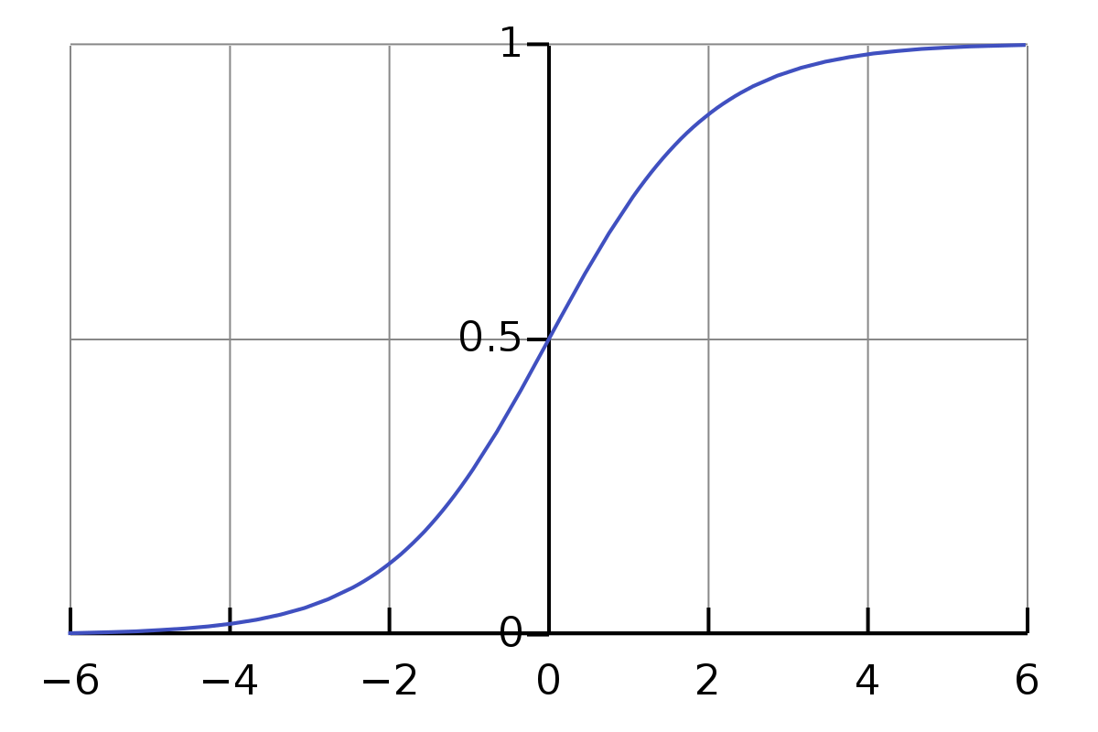**Sigmoid function**

This is a function that maps **R** to (0,1) as shown

It is defined as **σ(x) = 1/1+e-x**

#### 1) Model

Since this is a binary classification problem, the prediction is either 0 or 1. We first develop a linear model on the data (z = w.x + b). Then we apply the linear model on a sigmoid function to get the probability that the output is 1.

So, f(x) = 1/1+e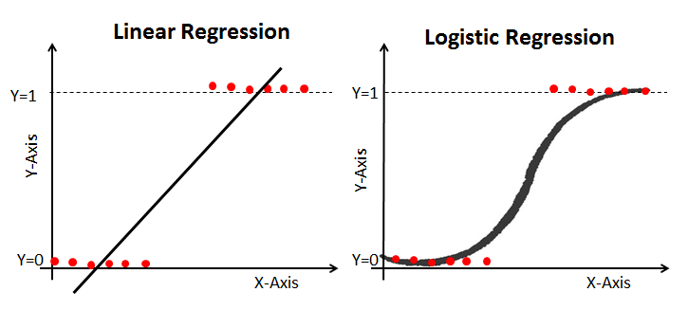-z

where z = w.x + b

i.e, **f(x) = 1/1+e-(w.x + b)**

#### 2) Optimisation function

We now need to define a cost function, which is to be optimised for finding the optimal values w* and b*. We cannot use the MSE cost function because it would lead to a non-convex curve, making it difficult for optimisation algorithms such as G.D to optimise [ G.D might get stuck in a local minima].

So we define logistic loss function as

- log(f(x)) if y == 1

Loss =

- log(1 – f(x)) if y == 0

or,

**Loss = - y log(f(x)) – (1 – y) log(1 – f(x))**

Since cost is the loss over the whole dataset,

Cost function = -(1/m) Σi=1m [ y log(f(x)) + (1 – y) log(1 – f(x)) ]

This is convex and can be used by G.D to find w* and b*.

# 3. Decision Tree Algorithm

The Decision Tree Algorithm is a supervised ML algorithm that leverages tree data structure. Every input is passed into a tree structure. In each branching node of the tree, a specific feature of the feature vector is examined. If the value of the feature is below a specific threshold, then the left branch is followed; otherwise, the right branch is followed. As the leaf node is reached, the decision is made about the class to which the example belongs.

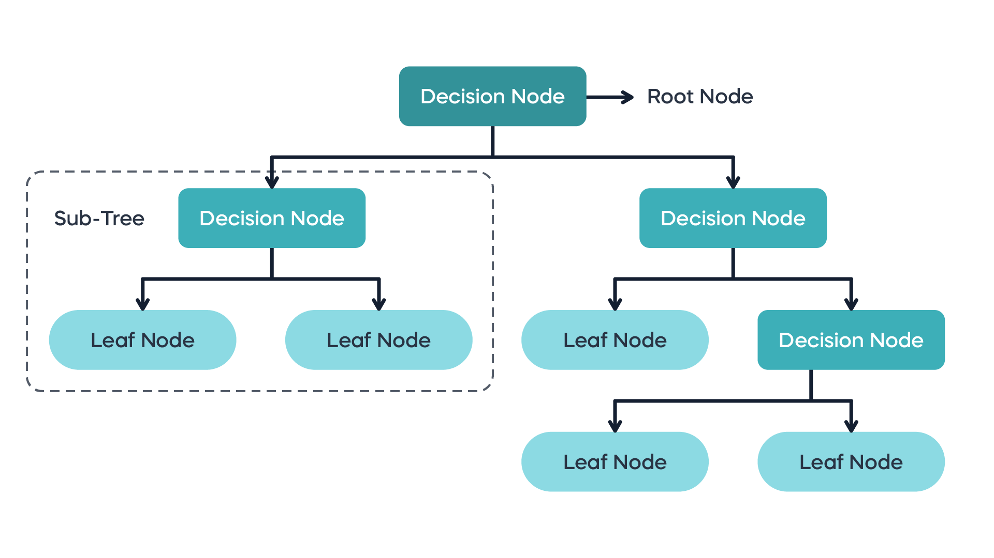

Decision Trees are non parametric in nature. **Non-parametric** models make fewer assumptions about the underlying data distribution and aim to capture patterns directly from the data. These models can adapt to more complex relationships without assuming a specific functional form. They often require storing the entire training dataset, making them memory-intensive. They don’t create something which can be used to perform inference (like Linear regression finds w* and b* )

They are of two types:

1. Classification trees
2. Regression trees

# 4. Support Vector Machines (SVM)

SVM sees every feature vector as a point in a high-dimensional space. The algorithm puts all feature vectors on an imaginary n-dimensional plot and draws an imaginary (n-1) dimensional hyperplane[decision boundary] that separates examples with positive labels from examples with negative labels.

The equation of the hyperplane is given by two parameters, a real-valued vector w of the same dimensionality as our input feature vector x, and a real number b like this:

**wx − b = 0**  (some people use wx + b = 0)

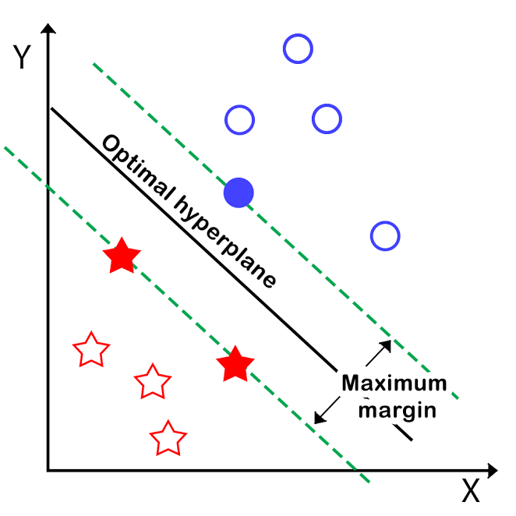We would also prefer that the hyperplane separates positive examples from negative ones with the largest margin, as it contributes to a better generalization. To achieve that, we needto minimize the Euclidean norm of w denoted by ||w||.

The goal of SVM is to leverage the dataset and find the optimal values w* and b* for parameters w and b. Once the learning algorithm identifies these optimal values, the model f (x) is then defined as:

**f(x) = sign(w*. x − b* )**

Thus, SVM creates a decision boundary on the data, which can be used for classification. It is very similar to linear regression, except for the fact that SVM tries to find a line that best separates the data points, while L.Regression tries to model a line that best fits in the data points.

#### Kernel trick

If the datapoints cannot be separated by a linear hyperplane (inherent Non-Linearity in data), what will we do? Indeed, if we manage to transform the original space into a space of higher dimensionality, we could hope that the examples will become linearly separable in this transformed space. In SVMs, using a function to implicitly transform the original space into a higher dimensional space during the cost function optimization is called the kernel trick.

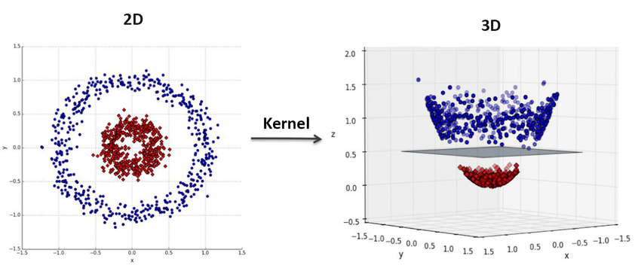

# 5. k-Nearest Neighbors

k-Nearest Neighbors (kNN) is a non-parametric learning algorithm. Contrary to other learning algorithms that allow discarding the training data after the model is built, kNN keeps all training examples in memory. Once a new, previously unseen example x comes in, the kNN algorithm finds k training examples closest to x and returns the majority label, in case of classification, or the average label, in case of regression. This comparison is done using methods like Euclidean distance or negative cosine similarity.